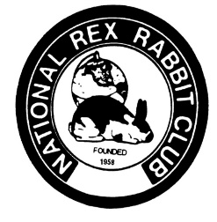
National Rex Rabbit Club
Chartered 1958
Request For Breeder Listing

Name(s):______________________________________________________ Rabbitry Name: ______________________________ ________________________________________________________________________________

eMail: ______________________________________ Check to list Phone: ___________________________ Check to list

Address: _________________________________________ Check to list

City: ____________________ Check to list State: ______________ Zip Code: ___________ Check to list Zip______________________________________________________

Varieties raised:

____________________ _______________________________________________________ ____________________
_______________________________________ __________________ _________________________________________

One year listing RexWorld and Website $10 Three year listing Rex World and Website $25

Please mail this form with payment to:

National Rex Rabbit Club
Arlyse DeLoyola, Secretary
PO Box 1465
Cave Junction, OR 97523
nationalrex@yahoo.com

