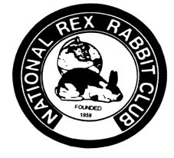
ELECTION NOMINATION PETITION
NATIONAL REX RABBIT CLUB
Any member with at least three consecutive years of membership in the National Rex Rabbit Club, Inc., in good standing, wishing to become a candidate for any elective office of the National Rex Rabbit Club, Inc. shall write to the Secretary-Treasurer for a nomination petition which the Secretary-Treasurer shall supply. (You may copy this petition in lieu of requesting one from the secretary) The nomination petition shall be completed by the member and show the member’s name and the office for which he/she is a candidate, be signed by him/her, and shall, in addition, be signed by ten (10) members in good standing of the National Rex Rabbit Club, Inc. The petition must then be returned, postmarked by July 1st, to the Secretary-Treasurer. The Secretary-Treasurer shall place the name of the member appearing on the petition, and the office for which he/she is a candidate on the election ballot.
This petition is for the office of:
_____President (even years only) _____Vice President (odd years only) _____Director
We, the undersigned, hereby endorse the above candidate to run for the selected office. We affirm that we are members in good standing of the National Rex Rabbit Club.
Printed Name Signature email Address

Petitions must be returned to the Secretary Postmarked no later than July 1st. Mail to:
NRRC Arlyse DeLoyola PO Box 1465 Cave Junction OR 97523-1465

